DINISHA R

230701080

**DESIGN AND ANALYSIS OF ALGORITHM**

**DIVIDE AND CONQUER**

1)

Given an array of 1s and 0s this has all 1s first followed by all 0s. Aim is to find the number of 0s. Write a program using Divide and Conquer to Count the number of zeroes in the given array.  
Input Format  
   First Line Contains Integer m – Size of array  
   Next m lines Contains m numbers – Elements of an array  
Output Format  
   First Line Contains Integer – Number of zeroes present in the given array.

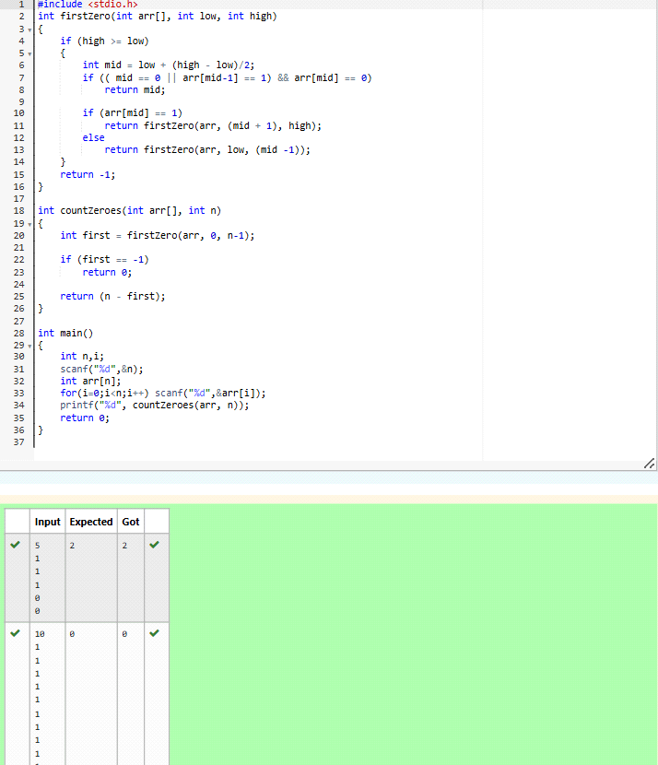

2)

Given an array nums of size n, return *the majority element*.

The majority element is the element that appears more than ⌊n / 2⌋ times. You may assume that the majority element always exists in the array.

**Example 1:**

**Input:** nums = [3,2,3]

**Output:** 3

**Example 2:**

**Input:** nums = [2,2,1,1,1,2,2]

**Output:** 2

**Constraints:**

* n == nums.length
* 1 <= n <= 5 * 104
* -231 <= nums[i] <= 231 - 1

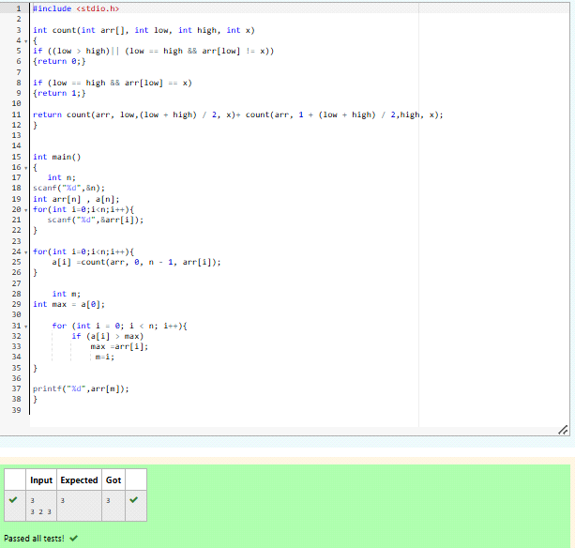

3)

Given a sorted array and a value x, the floor of x is the largest element in array smaller than or equal to x. Write divide and conquer algorithm to find floor of x.  
**Input Format**  
   First Line Contains Integer n – Size of array  
   Next n lines Contains n numbers – Elements of an array  
   Last Line Contains Integer x – Value for x  
   
**Output Format**  
   First Line Contains Integer – Floor value for x

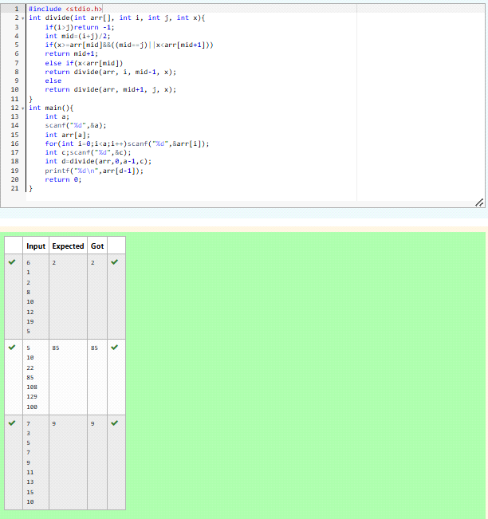

4)

Given a sorted array of integers say arr[] and a number x. Write a recursive program using divide and conquer strategy to check if there exist two elements in the array whose sum = x. If there exist such two elements then return the numbers, otherwise print as “No”.  
Note: Write a Divide and Conquer Solution  
**Input Format**  
   First Line Contains Integer n – Size of array  
   Next n lines Contains n numbers – Elements of an array  
   Last Line Contains Integer x – Sum Value  
**Output Format**  
   First Line Contains Integer – Element1  
   Second Line Contains Integer – Element2 (Element 1 and Elements 2 together sums to value “x”)

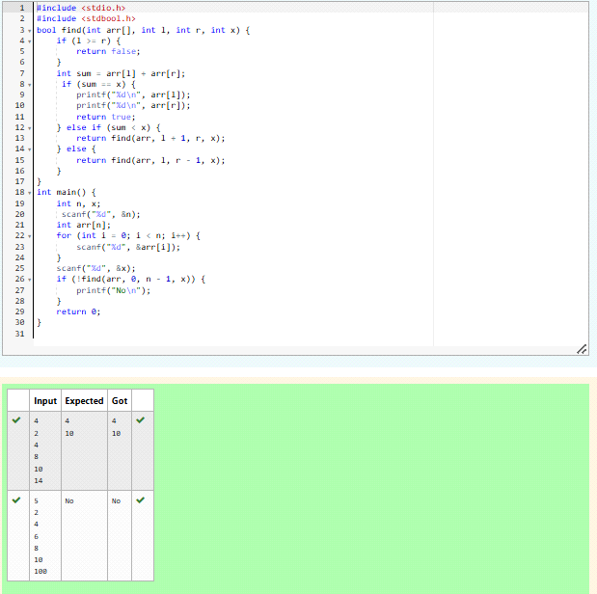

5)

Write a Program to Implement the Quick Sort Algorithm  
  
Input Format:  
The first line contains the no of elements in the list-n  
The next n lines contain the elements.  
  
Output:  
Sorted list of elements

